1) Suddenly, the world she knew had disappeared.
2) Lola felt like a rocket flying through space.
3) The fluffy clouds below her looked like a bed of candy floss.
4) Lola now knew why being on top of the world was an immense feeling.

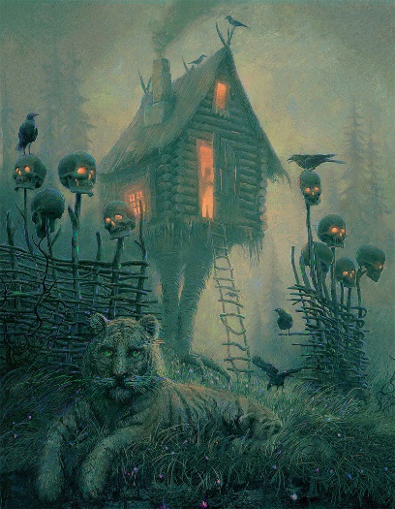
1) Dr Turner peeked anxiously out of the doorway, sweat dripping into his eye.
nxio
2) The skulls on the fence suddenly lit up orange. It was time.

3) The tiger protected the house like it was his prey.

4) The house had stood still, almost as if it was waiting for permission to pass.

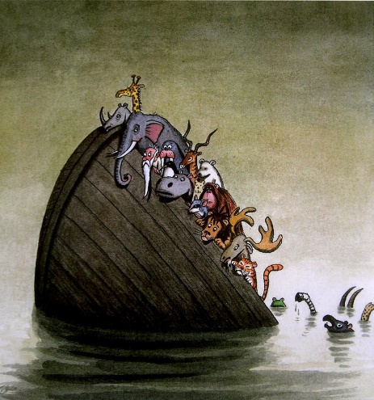
1) Lion knew escaping was a dangerous decision.

2) At that moment, predators and prey were united in fear.

3) The water seemed calm as it began to swallow the boat.

4) As the boat slowly descended into the sea, there was a light.

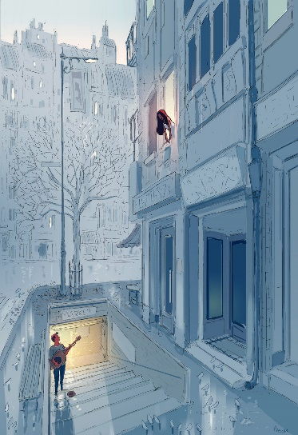
1) The sweet sounds of Jack’s guitar filled the crisp, winter’s air.

2) Sofia leaned excitedly out of her second-floor window.

3) “Let me show you this town like you’ve never seen it before,” dared Jack.

4) Sofia’s heart fluttered as Jack gazed into her deep, hazel eyes.

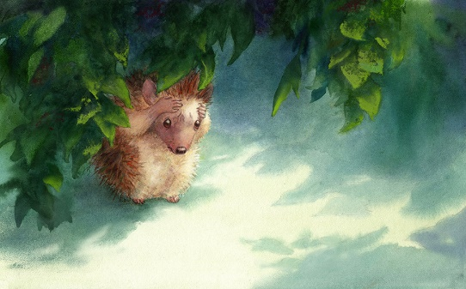
1) Oscar wrapped his arms around his head in fear.
2) This was a monumental leap of faith. He didn’t know if he was ready.
3) Oscar emerged from the shadows of the trees.
4) ‘Oh no!,’ Oscar thought to himself.

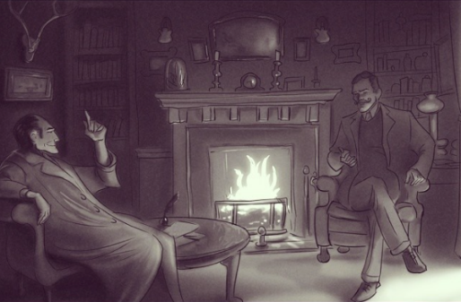
1) The fire burned furiously as the strange looking man delivered his terrible news.
2) “I will get to the bottom of this John. It’s what you pay me for.”
3) Malcolm lifted his finger, pointing up towards the ceiling.
4) John crossed his legs in an attempt to hide his anxiousness.

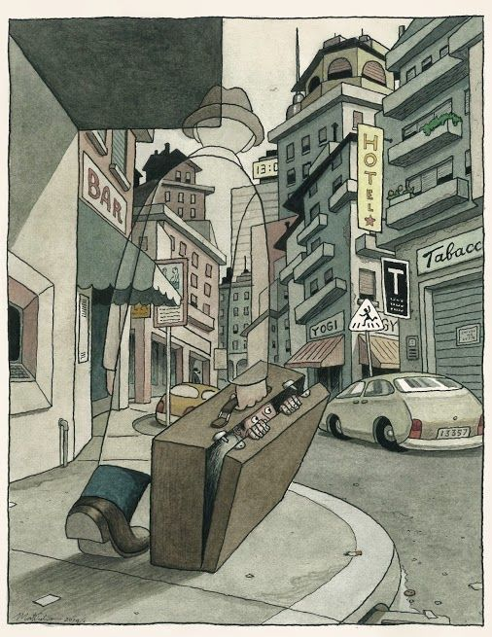
1) Tommy’s eyes peered out of the suitcase.

2) There were lots of good things about being invisible.

3) He plodded towards the hotel as a lonely car pulled up on the road.

4) The town was eerily silent. Even the birds had migrated to a happier place.

been
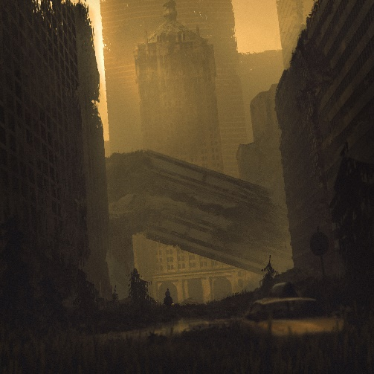
1) The thrum, hum and buzz of the city had been replaced by…

2) The taste of dust and destruction filled the mouths of the survivors.

3) The buildings toppled like Jenga as the air filled with the monster’s roar.

4) ‘Why did this have to happen?’ thought Mrs. Carter to herself.

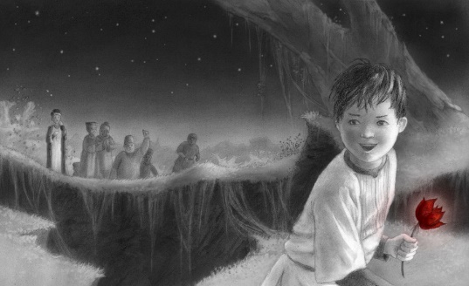
1) “Come back here, thief!” demanded the old, grey man.
2) Harry clung onto the rose as it shimmered in the moonlight.
3) The magic rose was finally in his hands.
4) Harry hopped over the mound with the wind behind him.

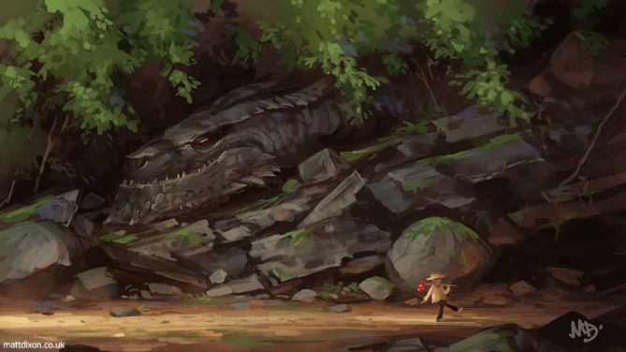
1) Jack wandered merrily through the forbidden woods.
2) Suddenly, stones and twigs tumbled onto the dusty floor.
3) In that moment, as Jack took one more gleeful stride…
4) It was like the leaves on the trees were talking to Jack.

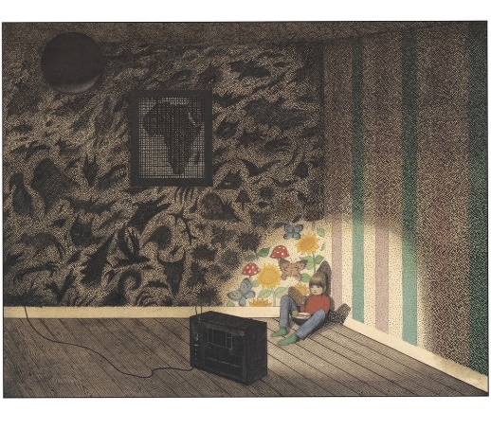

1)The room was shrouded in darkness but for the torch of a television set.
2) Isabella had clambered into the corner of her bedroom.
3) The room. The house. Her spirit. They all felt empty.
4) Isabella put the video cassette into the TV. Just one more watch before bed.

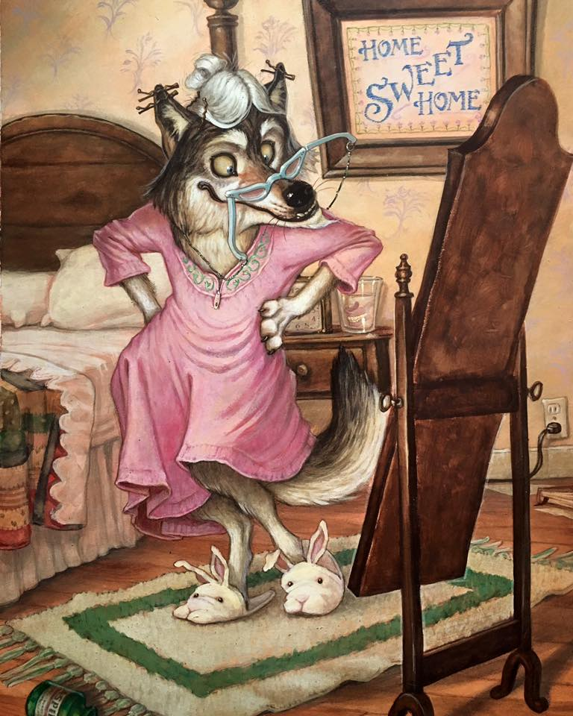
1) Wolf imagined herself on the cat walk and what posture she’d have.

2) “Who’s the fairest wolf of them all?” asked the Wolf.

3) The cries from the cupboard didn’t seem to bother the wolf.

4) Wolf liked her shoes, but she couldn’t help but feel they looked tasty.

