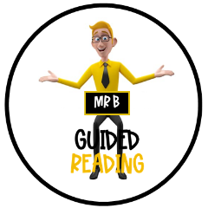

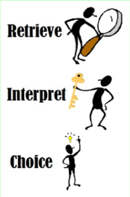
Early Man Film Trailer (2018)
What sport do they play in the arena?

Why was everyone shocked to see the caveman?
How does the producer persuade you to watch the film?

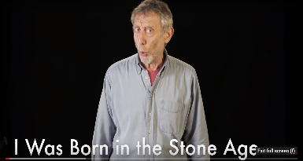
What did they write with in the Stone Age?

Why was
Why are rocks important in this poem?
‘I was born in the Stone Age’ – Poem by Michael Rosen
How does the poet make the Stone Age sound unappealing?

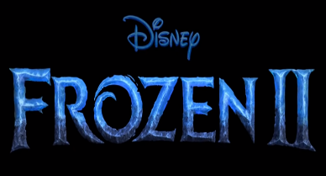
What colour was the heart of fire?

How did Elsa feel as she was running into the sea?
Frozen II film trailer (2019)
How does the trailer make you want to go and watch the film?

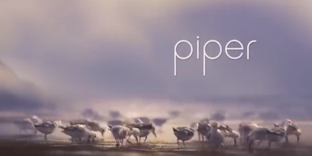
What did all the birds run away from?

Piper – Disney Pixar – Oscar winning short movie (2016)
How does Piper get more confident in the water?

Why does the producer include a shot of the sunset?
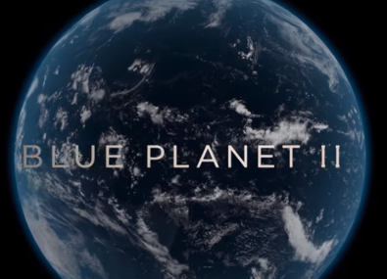
When did Blue Planet ‘open our eyes to the world under the waves’?

Why did the producer use slow motion shots?

Why does the video tell us to ‘take a deep breath’?
Blue Planet II trailer (BBC, 2018)

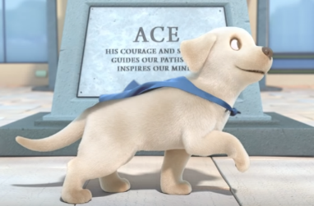
Where was Pip learning how to be a guide dog?
How did Pip feel after exam day?
PIP – a short animated film (2018)
What was the message of the video?

What material should you draw the fins on?

How does the producer make the instructions easy to follow?
Instructions: How To Build a Rocket (Puffin Books)
Why does the producer use music in the video?

What is the yeti’s name?

Why does the girl want to escape?
Abominable Film Trailer (2019)

Why did the yeti want to escape from his last owner?

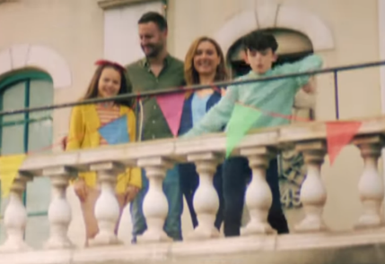

How much does it cost for 4 people?
Why is there a boy dancing in the advert?
Get that Thomas Land Feeling, Drayton Manor Advert (2019)
Does this advert make you want to go to Thomas Land?

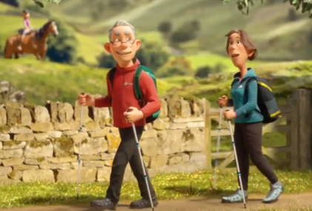
What was the man holding by the river?

How does this advert encourage you to go outside?
Go Outdoors Advert (2019)

Who is this advert aimed at?

I opened a book and in I strode
Now nobody can find me.
I’ve left my chair, my house, my road,
My town and my world behind me.
I’m wearing the cloak, I’ve slipped on the ring,
I’ve swallowed the magic potion.
I’ve fought with a dragon, dined with a king Who did the narrator fight with?
And dived in a bottomless ocean.
I opened a book and made some friends.
I shared their tears and laughter Why does the narrator wear a cloak?
And followed their road with its bumps and bends
To the happily ever after.
I finished my book and out I came. What is the message of the poem?
The cloak can no longer hide me.
My chair and my house are just the same,
But I have a book inside me.
Julia Donaldson – I opened a book (Poem, 2004)

Round the world and home again
That's the sailor's way
Faster faster, faster faster
There's no earthly way of knowing
Which direction we are going What was the weather like?
There's no knowing where we're rowing
Or which way the river's flowing
Is it raining, is it snowing How do we know it was scary to be a sailer?
Is a hurricane a–blowing
Not a speck of light is showing
So the danger must be growing
Are the fires of Hell a–glowing
Is the grisly reaper mowing Why does the poet use rhyme in every line?
Roald Dahl – The Rowing Song (Poem)
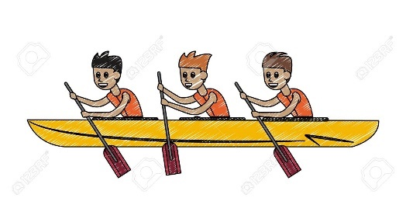
Yes, the danger must be growing
For the rowers keep on rowing
And they're certainly not showing
Any signs that they are slowing.

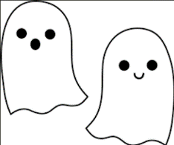
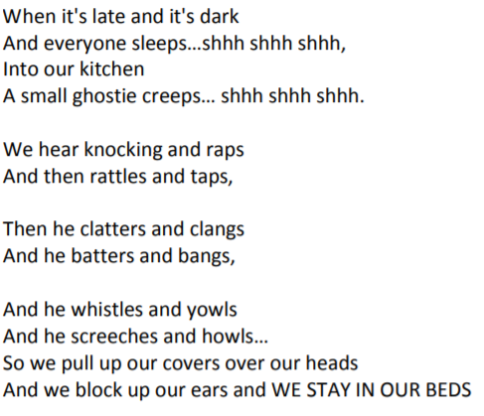
Who lives in this house?
How would you describe the ghost?
Where did the small ghostie creep?
Barbara Ireson – The Small Ghostie (Poem)

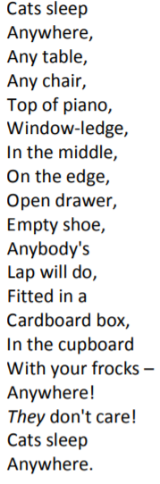
Where would you find the frocks?

How would you describe cats after reading this poem?

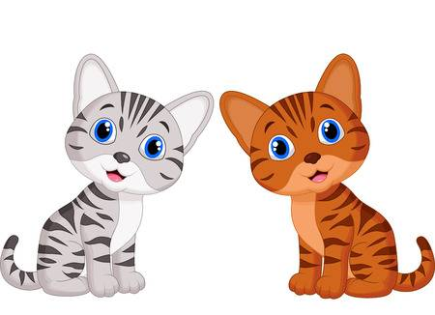
Why are all the lines of the poem so short?

Eleanor Farjeon – Cats (Poem)

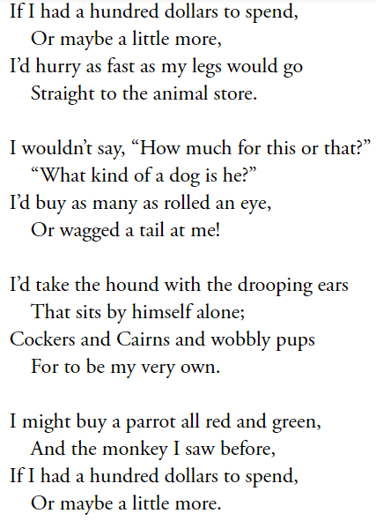
Rachel Field – The Animal Store (Poem)
What animals does the narrator say they’ll buy?

How do we know the narrator wants to buy lots of dogs?

Why does the narrator want to buy so many animals?

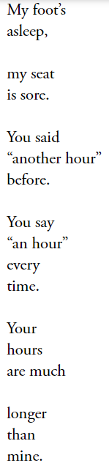
David L Harrison – Are We There Yet? (Poem)

How does the narrator describe their foot?

Why is the narrator so frustrated?

Where is the narrator going?

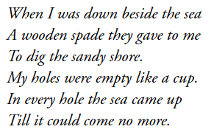
What simile is used in the poem?

Who is the narrator with at the seaside?

What does the poet mean by ‘till it could
come no more’?
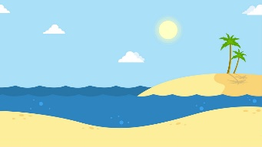
Robert Louis Stevenson – At The Seaside (Poem)

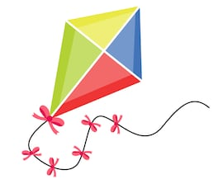
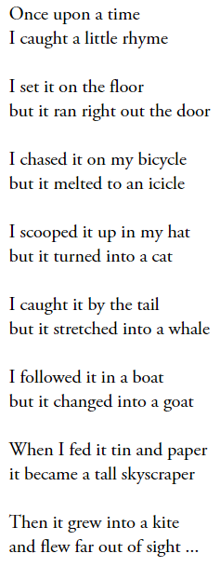
Why did the poet write this poem?
Why does the poet use rhyming couplets?
How did the narrator chase the rhyme?
Eve Merriam – Catch a little rhyme (Poem)

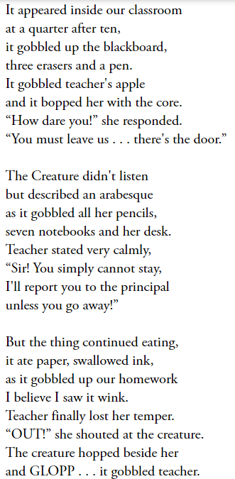

Jack Prelutsky – The Creature In Our Classroom (Poem)
What verb is repeated to show how the creature eats?

How do we know the creature is cheeky?

Where did the creature come from?
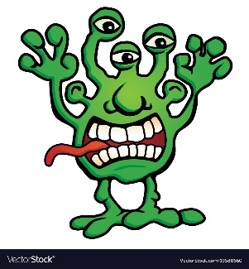

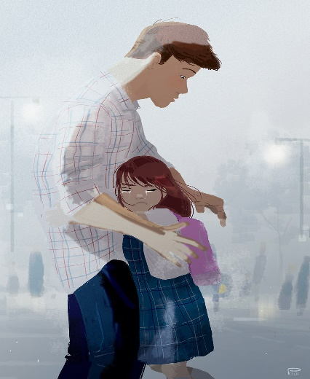

What colour is the girl’s rucksack?

How is the girl feeling and why?

Where are they?

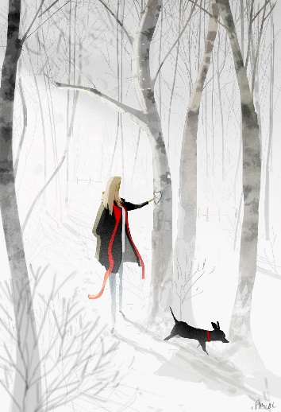

Who is the girl walking with?

What time of year is this?

Why is she touching the tree?

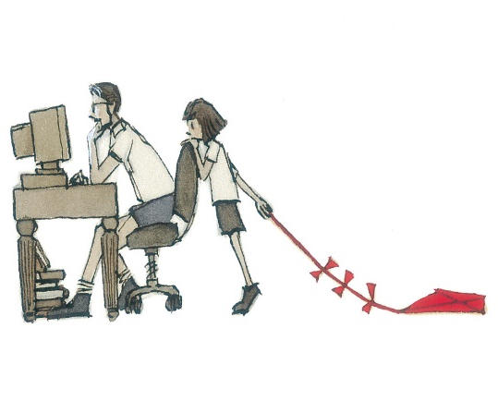
What is the daughter holding?

What is Dad doing on the computer?

What is the girl saying to Dad?

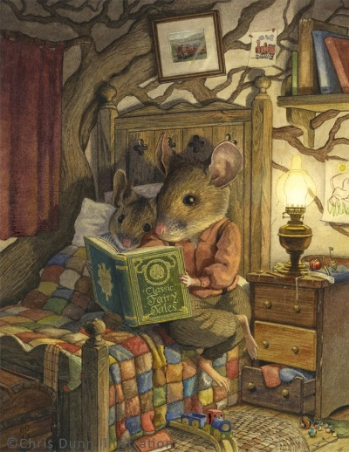
What are the mice reading?

What can we tell about the young mouse’s personality?

Where are they reading this book?

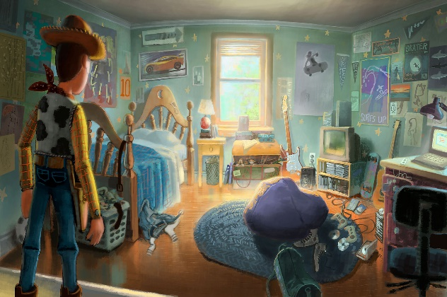
What instrument does Andy play?

What type of person is Andy?

How does Woody feel as he looks at
the bedroom?

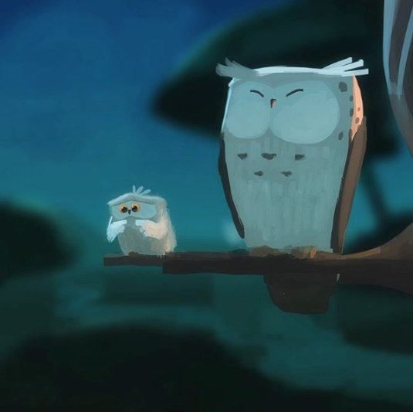
What are the owls sitting on?

How is the small owl feeling and why?

What advice might big owl give to small
owl?

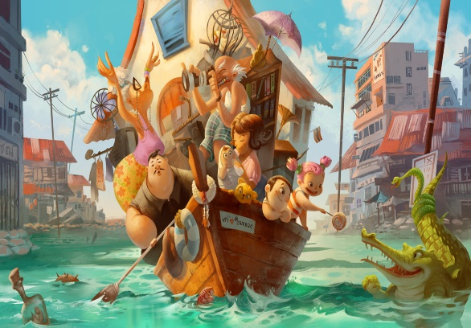
What is the small girl giving the crocodile?

How do the people feel on the boat and why?

Where are they going?

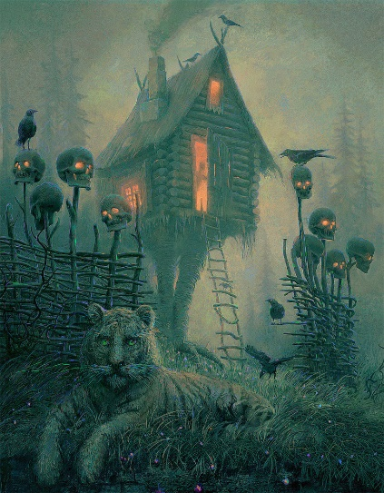

How do you get into the house?

Why is there a tiger outside the house?

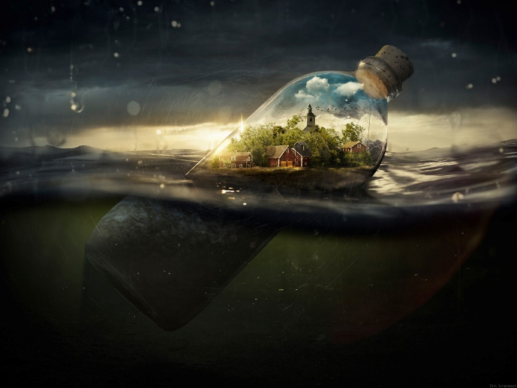
Who lives in this house?

Where is the bottle?

Why is there a house in the bottle?

Where is the bottle floating to?

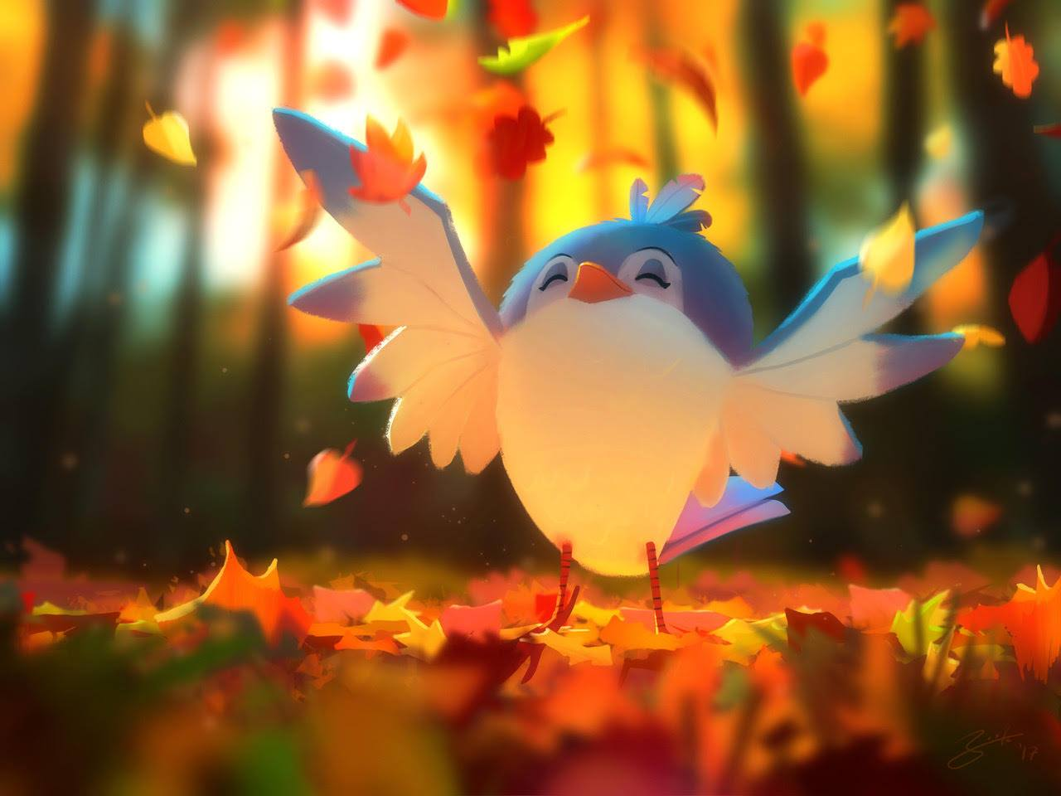
What is falling on the ground?

Why is the bird happy?

What do you like most about autumn?

